Additional File 1
Sex-specific patterns of senescence in artificial insect populations varying in sex-ratio to manipulate reproductive effort

Supplementary table and figures

Table S1: AICc values for the models presented in Tables 2 and 3. The models in bold are those presented in the tables.

Fertility females
Models | AICc
Fertility ~ Age * Sex-ratio + Female Mass + (|replicate) | 7627.5
Fertility ~ Age + Female Mass + (|replicate) | 7668.2
Fertility ~ Age + Sex-ratio + Female Mass + (|replicate) | 7671.5
Fertility ~ Age * Sex-ratio + (|replicate) | 7773.8
Fertility ~ Age + (|replicate) | 7777.3
Fertility ~ Age + Sex-ratio + (|replicate) | 7779.0
Fertility ~ Female Mass + (|replicate) | 8089.8
Fertility ~ Sex-ratio + Female Mass + (|replicate) | 8092.2
Fertility ~ Sex-ratio + (|replicate) | 8325.3
Fertility males
Models | AICc
Fertility ~ Age + Female Mass + (|replicate) | 16522.1
Fertility ~ Age * Sex-ratio + Female Mass + Male Mass + (|replicate) | 16530.8
Fertility ~ Age + Sex-ratio + Female Mass + (|replicate) | 16532.9
Fertility ~ Age + Female Mass + Male Mass + (|replicate) | 16533.7
Fertility ~ Age + Sex-ratio + Female Mass + Male Mass + (|replicate) | 16534.4
Fertility ~ Female Mass + Male Mass + (|replicate) | 16725.5
Fertility ~ Sex-ratio + Female Mass + Male Mass + (|replicate) | 16725.8
Fertility ~ Female Mass + (|replicate) | 16730.5
Fertility ~ Sex-ratio + Female Mass + (|replicate) | 16731.2
Fertility ~ Age + Sex-ratio + (|replicate) | 16778.7
Fertility ~ Age + (|replicate) | 16779.0
Fertility ~ Age + Sex-ratio + Male Mass + (|replicate) | 16780.7
Fertility ~ Age + Male Mass + (|replicate) | 16781.0
Fertility ~ Sex-ratio + Male Mass + (|replicate) | 17057.5
Fertility ~ Male Mass + (|replicate) | 17058.3
Fertility ~ Sex-ratio + (|replicate) | 17060.5
Body condition females
Models | AICc
Body condition ~ Age + Sex ratio + Age*Sex-ratio + (|replicate) | 1700.5
Body condition ~ Age + Sex ratio + (|replicate) | 1712.1
Body condition ~ Age + (|replicate) | 1714.6
Body condition ~ Sex ratio + (|replicate) | 1760.6
Body condition males
Models | AICc
Body condition ~ Age + Sex ratio + Age*Sex-ratio + (|replicate) | 1785.8
Body condition ~ Age + Sex ratio + (|replicate) | 1794.5
Body condition ~ Age + (|replicate) | 1794.7
Body condition ~ Sex ratio + (|replicate) | 1816.5
PO females
Models | AICc
PO ~ Age + Sex ratio + Age*Sex-ratio + Body condition + (|replicate) | 2164.3
PO ~ Age + Sex ratio + Age*Sex-ratio + (|replicate) | 2167.8
PO ~ Age + Sex ratio + Body condition + (|replicate) | 2191.0
PO ~ Age + Sex ratio + (|replicate) | 2194.2
PO ~ Age + Body condition + (|replicate) | 2195.9
PO ~ Age + (|replicate) | 2198.4
PO ~ Sex ratio + (|replicate) | 2219.5
PO ~ Sex ratio + Body condition + (|replicate) | 2220.1
PO ~ Body condition + (|replicate) | 2224.9
PO males
Models | AICc
PO ~ Age + Sex ratio + Age*Sex-ratio + (|replicate) | 2318.2
PO ~ Age + Sex ratio + Age*Sex-ratio + Body condition + (|replicate) | 2319.3
PO ~ Age + Sex ratio + (|replicate) | 2353.9
PO ~ Age + Sex ratio + Body condition + (|replicate) | 2354.6
PO ~ Age + (|replicate) | 2362.2
PO ~ Age + Body condition + (|replicate) | 2362.9
PO ~ Sex ratio + (|replicate) | 2386.3
PO ~ Sex ratio + Body condition + (|replicate) | 2387.5
PO ~ Body condition + (|replicate) | 2395.9
Total PO females
Models | AICc
Total PO ~ Age + Sex ratio + Age*Sex-ratio + Body condition + (|replicate) | 2044.4
Total PO ~ Age + Sex ratio + Age*Sex-ratio + (|replicate) | 2047.7
Total PO ~ Age + Sex ratio + Body condition + (|replicate) | 2071.9
Total PO ~ Age + Sex ratio + (|replicate) | 2075.0
Total PO ~ Age + Body condition + (|replicate) | 2079.2
Total PO ~ Age + (|replicate) | 2081.8
Total PO ~ Sex ratio + (|replicate) | 2112.4
Total PO ~ Sex ratio + Body condition + (|replicate) | 2114.3
Total PO ~ Body condition + (|replicate) | 2122.0
Total PO males
Models | AICc
Total PO ~ Age + Sex ratio + Age*Sex-ratio + (|replicate) | 2429.1
Total PO ~ Age + Sex ratio + Age*Sex-ratio + Body condition + (|replicate) | 2430.6
Total PO ~ Age + Sex ratio + (|replicate) | 2465.6
Total PO ~ Age + Sex ratio + Body condition + (|replicate) | 2466.7
Total PO ~ Age + (|replicate) | 2475.3
Total PO ~ Age + Body condition + (|replicate) | 2476.5
Total PO ~ Sex ratio + (|replicate) | 2485.5
Total PO ~ Sex ratio + Body condition + (|replicate) | 2487.2
Total PO ~ Body condition + (|replicate) | 2496.9
Haemocytes females
Models | AICc
Haemocytes ~ Age + (|replicate) | 573.4
Haemocytes ~ Sex ratio + (|replicate) | 574.6
Haemocytes ~ Body condition + (|replicate) | 575.6
Haemocytes ~ Age + Sex ratio + (|replicate) | 582.8
Haemocytes ~ Age + Body condition + (|replicate) | 583.9
Haemocytes ~ Sex ratio + Body condition + (|replicate) | 584.8
Haemocytes ~ Age + Sex ratio + Body condition + (|replicate) | 593.3
Haemocytes ~ Age + Sex ratio + Age*Sex-ratio + (|replicate) | 598.9
Haemocytes ~ Age + Sex ratio + Age*Sex-ratio + Body condition + (|replicate) | 609.5
Haemocytes males
Models | AICc
Haemocytes ~ Age + (|replicate) | 608.7
Haemocytes ~ Age + Body condition + (|replicate) | 618.0
Haemocytes ~ Age + Sex ratio + (|replicate) | 618.4
Haemocytes ~ Body condition + (|replicate) | 626.1
Haemocytes ~ Sex ratio + (|replicate) | 626.8
Haemocytes ~ Age + Sex ratio + Body condition + (|replicate) | 627.8
Haemocytes ~ Sex ratio + Body condition + (|replicate) | 635.8
Haemocytes ~ Age + Sex ratio + Age*Sex-ratio + (|replicate) | 637.4
Haemocytes ~ Age + Sex ratio + Age*Sex-ratio + Body condition + (|replicate) | 646.8
Antibacterial activity (proportion) females
Models | AICc
Antibacterial activity ~ Age (|replicate) | 259.4
Antibacterial activity ~ Age + Body condition + (|replicate) | 260.2
Antibacterial activity ~ Age + Sex ratio + (|replicate) | 262.3
Antibacterial activity ~ Age + Sex ratio + Body condition + (|replicate) | 262.9
Antibacterial activity ~ Age + Sex ratio + Age*Sex-ratio +(|replicate) | 266.1
Antibacterial activity ~ Age + Sex ratio + Age*Sex-ratio + Body condition +(|replicate) | 266.2
Antibacterial activity ~ Body condition + (|replicate) | 297.1
Antibacterial activity ~ Sex ratio (|replicate) | 300.2
Antibacterial activity ~ Sex ratio + Body condition + (|replicate) | 300.7
Antibacterial activity (proportion) males
Models | AICc
Antibacterial activity ~ Age (|replicate) | 241
Antibacterial activity ~ Age + Sex ratio + (|replicate) | 242.8
Antibacterial activity ~ Age + Body condition + (|replicate) | 242.8
Antibacterial activity ~ Age + Sex ratio + Age*Sex-ratio +(|replicate) | 244.4
Antibacterial activity ~ Age + Sex ratio + Body condition + (|replicate) | 244.6
Antibacterial activity ~ Age + Sex ratio + Age*Sex-ratio + Body condition +(|replicate) | 246.2
Antibacterial activity ~ Body condition + (|replicate) | 249.9
Antibacterial activity ~ Sex ratio (|replicate) | 250.8
Antibacterial activity ~ Sex ratio + Body condition + (|replicate) | 251.8
Antibacterial activity (intensity) females
Models | AICc
Antibacterial activity ~ Age | 676.3
Antibacterial activity ~ Age + Body condition | 678.5
Antibacterial activity ~ Body condition | 678.8
Antibacterial activity ~ Sex ratio | 680.6
Antibacterial activity ~ Age + Sex ratio | 681.1
Antibacterial activity ~ Sex ratio + Body condition | 682.8
Antibacterial activity ~ Age + Sex ratio + Body condition | 683.2
Antibacterial activity ~ Age + Sex ratio + Age*Sex-ratio | 693.9
Antibacterial activity ~ Age + Sex ratio + Age*Sex-ratio + Body condition | 695.3
Antibacterial activity (intensity) males
Models | AICc
Antibacterial activity ~ Sex ratio | 452.8
Antibacterial activity ~ Sex ratio + Body condition | 455.0
Antibacterial activity ~ Body condition | 458.0
Antibacterial activity ~ Age + Sex ratio | 458.3
Antibacterial activity ~ Age | 460.2
Antibacterial activity ~ Age + Sex ratio + Body condition | 461.1
Antibacterial activity ~ Age + Body condition | 462.6
Antibacterial activity ~ Age + Sex ratio + Age*Sex-ratio | 470.9
Antibacterial activity ~ Age + Sex ratio + Age*Sex-ratio + Body condition | 474.5

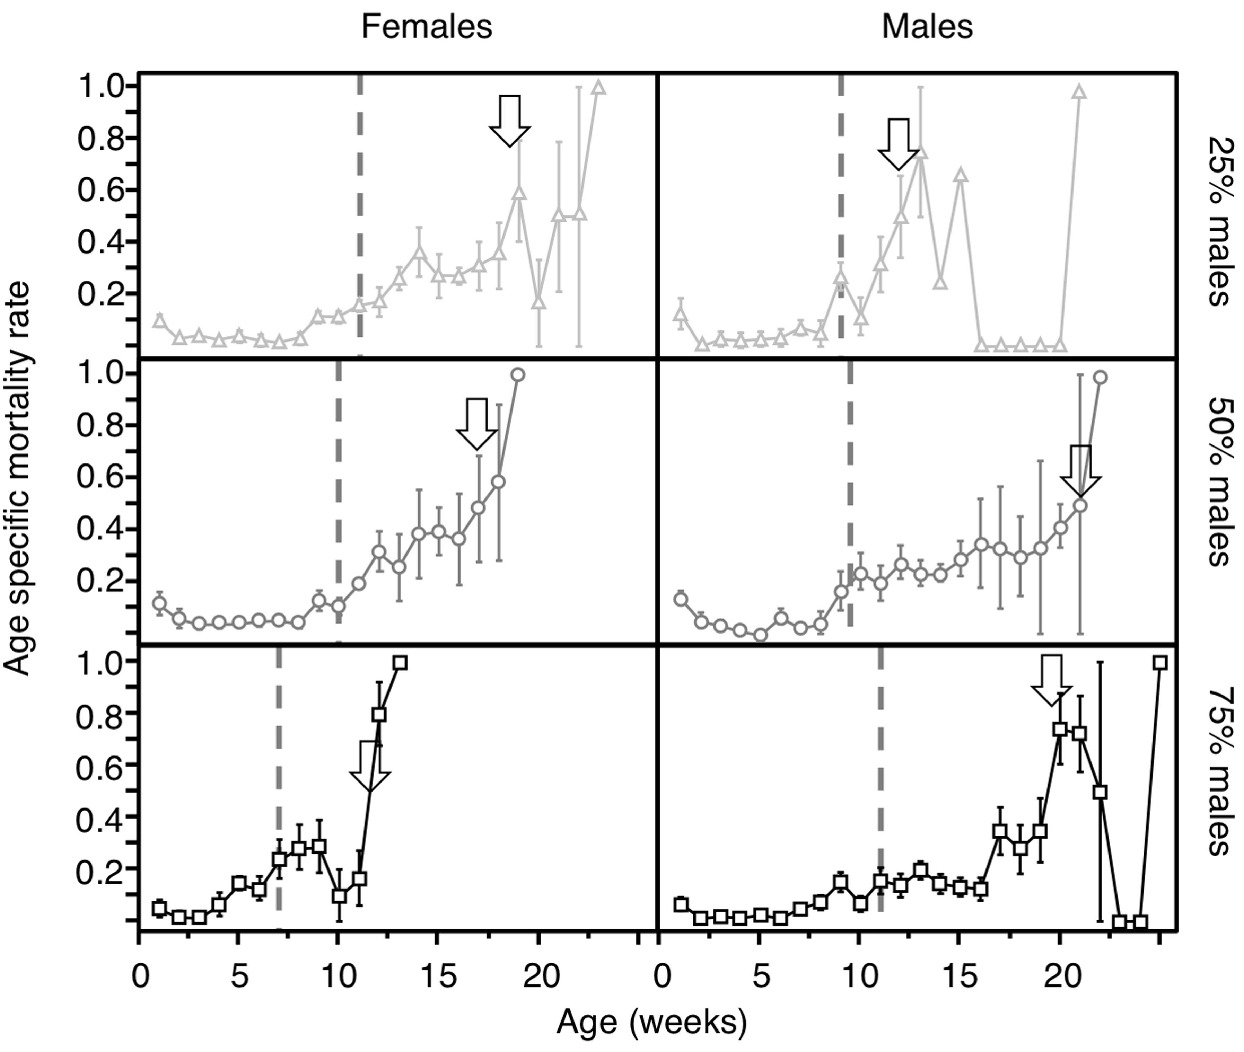

Fig. S1. Male and female age specific mortality rate according to time for each sex-ratio condition. Arrow marks the time when the values of 50% of mortality rate is reach for the fist time and dote line marks 50% of the population is dead. Values are means among replicates ± s. e. m.

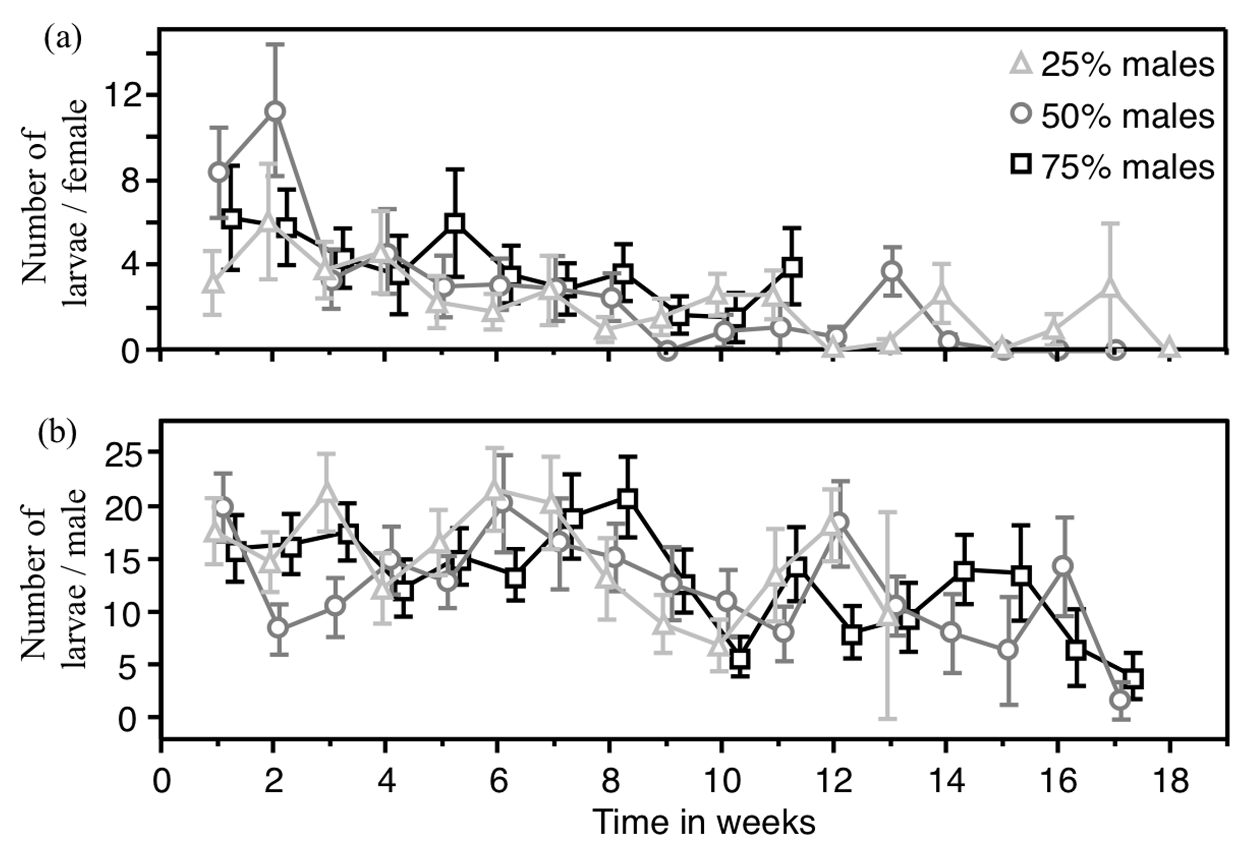

Fig. S2. Details of variation in fertility in females (A) and males (B). Values are means among replicates ± s. e. m.

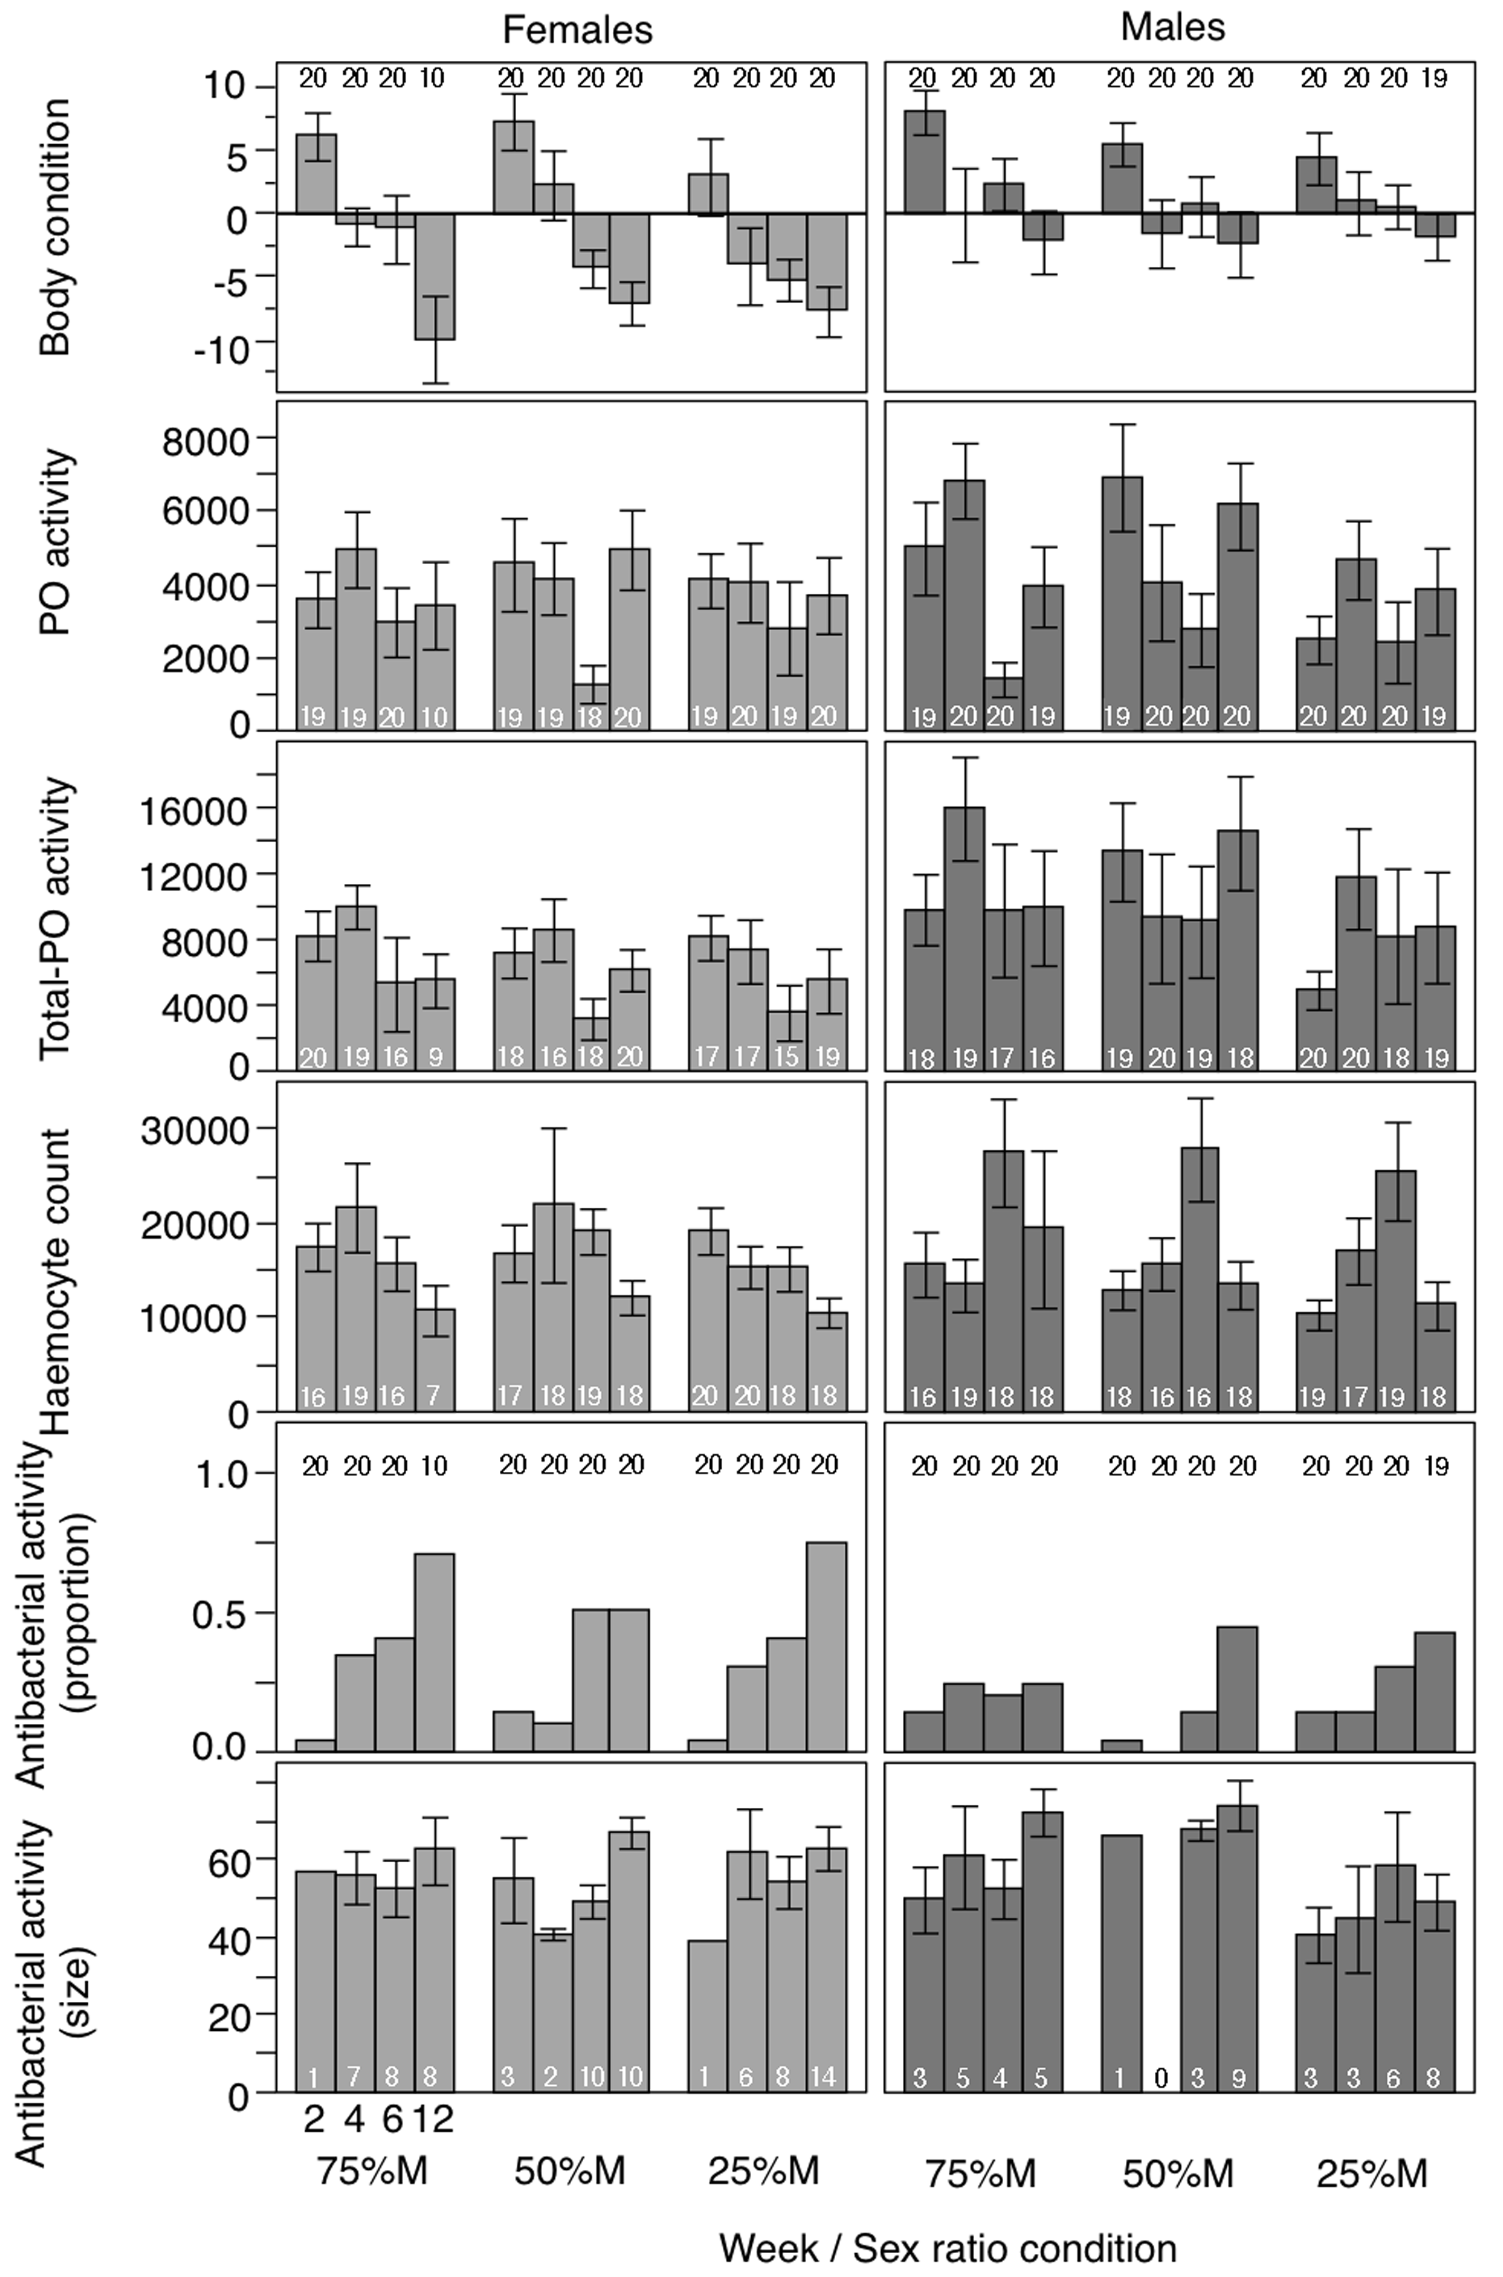
Fig. S3. Physiological parameters: females in bright grey and males in black. Body condition, PO activity according to time, PPO activity according to time and sex-ratio condition, Haemocyte count, Proportion of individuals producing antibacterial activity, Diameter of inhibition zone according to time and sex-ratio condition. Values are means among replicates ± s. e. m.

